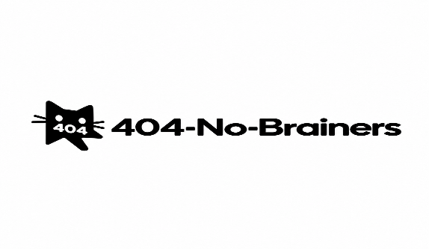

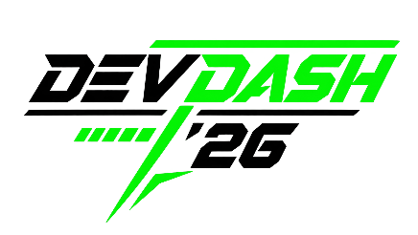

App name: UCL Connect
A Centralized Digital Platform for Campus Information and Student Services
One Campus. One Trusted Source.

Prepared for
Universal College Lanka
Prepared by
Team 404 No-Brainers

Team members
- Thusara Dinusith
- Sithijaya Ranasinghe
- Emesh Easterkumar
- Abhiman Sri Ranasinghe
- Upeksha Sathsarani
DevDash ’26
19 September 2026

Table of Contents
- Executive Summary
- Business Background and Problem Statement
- Project Objectives
- Scope and Requirement Prioritization
- Requirements Coverage
- Proposed Solution
- Design Process
- System Architecture and Technology Stack
- Implementation and Key Decisions
- Non-Functional Requirements
- Testing
- Validation
- Limitations and Future Development
- Conclusion
- Appendix

- Executive Summary

Universal College Lanka currently relies on a range of disconnected communication channels, including WhatsApp groups, lecturers, notice boards, student societies and word of mouth. As a result, students do not have a single authoritative source through which they can conveniently access campus-related information, while university staff may become the fallback point for routine enquiries.
To address this problem, our team developed UCL CONNECT, a digital platform designed to provide students with a central and reliable location for university information and services. The platform brings together important academic and campus information through a unified interface while providing different levels of access for students and authorized staff.
The prototype focuses on unified access, targeted announcements, event visibility, academic support, staff directory, IT support, AI-assisted information discovery, access levels, academic calendar and schedule changes. The solution was designed to prioritize usability, maintainability, controlled access and ease of information discovery within the limited DevDash ’26 development period.
This report documents the team's problem-solving approach, requirement prioritization, design process, architecture, implementation decisions, testing outcomes, validation, limitations and potential future development.

2. Business Background and Problem Statement

Students at Universal College Lanka currently obtain campus information from several disconnected sources. These include WhatsApp groups, lecturers, notice boards, student societies and informal word-of-mouth communication. There is currently no single channel regarded as the authoritative source for campus-related information.
This fragmentation extends across announcements, events, campus services, society activities and other aspects of university life. It can increase the time students spend looking for information and can also increase the workload of administrative staff when students depend on them for information that could otherwise be accessed independently.
The core business problem identified by UCL is therefore the absence of a reliable, trusted and unified channel through which students can access campus-related information and services.

3. Project Objectives
Based on the problem identified by UCL, the project aimed to contribute towards four broader outcomes:
A more informed and engaged student body; greater visibility for events, societies and campus services; less time spent by staff and students searching for basic information; and a stronger long-term digital foundation that UCL could potentially build upon beyond the hackathon.
Within the hackathon timeframe, our team therefore focused on implementing a practical subset of requirements that directly contributed to these objectives rather than attempting to implement all possible functionality superficially.

4. Scope and Requirement Prioritization
4.1 Project Scope
The DevDash ’26 problem statement defines a broad range of business requirements addressing campus communication, student services, academic information and university support. The brief allows development teams to determine which areas of the problem should be prioritized rather than requiring all requirements to be implemented equally.
Within the available development period, our team selected ten requirements that directly contribute to the core business problem: the lack of a single reliable source through which students can access university information and support services.
The selected scope focuses on providing students with centralized access to relevant information, personalized announcements, academic and technical support, important dates and schedule changes, staff contact information, events, controlled user access and an AI-assisted method of locating information.
The brief explicitly allows teams to focus on a subset of the requirements.
4.2 Selected Requirements

ID | Requirement | Priority | Reason for Selection
BR1 | Unified Access | High | Directly addresses the central information-fragmentation problem
BR2 | Targeted Announcements | High | Allows students to access information relevant to their programme/year/faculty
BR3 | Event Visibility | Medium | Improves awareness of university and student events
BR9 | Academic Support | High | Gives students easier access to academic help and support
BR12 | Access Levels | High | Protects official information and separates student/staff capabilities
BR13 | Academic Calendar | High | Centralizes important dates and academic deadlines
BR16 | Schedule Changes | High | Supports communication of closures and unexpected changes
BR22 | Staff Directory | Medium | Helps students quickly identify relevant university contacts
BR30 | IT Support Info | Medium | Gives students clear access to technical-support information
BR33 | AI Assistant | High | Provides conversational access to information and simplifies navigation

4.3 Prioritization Rationale
The selected requirements were chosen because they form a connected solution rather than a collection of unrelated features. Unified Access acts as the foundation of the system, while Targeted Announcements, Event Visibility, Academic Calendar and Schedule Changes provide students with relevant and time-sensitive information. Academic Support, Staff Directory and IT Support Information improve access to university assistance. Access Levels help ensure that sensitive or official functions are limited to authorized users, while the AI Assistant provides an alternative way for students to discover information using natural-language questions.
The team deliberately prioritized depth and integration across these selected requirements rather than attempting to implement all 33 business requirements with limited functionality.

5. Selected Requirements Coverage
The following table shows how the selected business requirements are represented within the proposed solution. Evidence references should be updated during final report preparation to correspond with screenshots and test results included later in the report.

ID | Requirement | Proposed Implementation | Evidence
BR1 | Unified Access | Central student dashboard providing access to selected campus information and services | Fig. 1
BR2 | Targeted Announcements | Announcement area displaying information relevant to appropriate student groups | Fig. 2
BR3 | Event Visibility | Events section displaying upcoming university and student-related activities | Fig. 3
BR9 | Academic Support | Dedicated section providing students with access to academic-support information | Fig. 4
BR12 | Access Levels | Different permissions for student and authorised staff accounts | Fig. 5
BR13 | Academic Calendar | Central view of relevant academic dates, deadlines and milestones | Fig. 6
BR16 | Schedule Changes | Communication area for closures and unexpected schedule updates | Fig. 7
BR22 | Staff Directory | Searchable/viewable contact information for relevant staff and departments | Fig. 8
BR30 | IT Support Info | Central access to IT and technical-support information | Fig. 9
BR33 | AI Assistant | Conversational interface helping students locate information more quickly | Fig. 10
Requirement Coverage Strategy
The prototype is designed so that these ten requirements operate through a common platform. Rather than requiring students to use separate tools for announcements, academic dates, events and support information, each selected requirement is accessible from the same central interface.

6. Proposed Solution
6.1 Solution Overview

UCL CONNECT is a digital campus-information platform designed to give Universal College Lanka students one central location for accessing important university information, academic resources and support services.
The platform combines ten selected business requirements within a unified interface. Students can access personalized announcements, upcoming events, academic-support resources, important calendar dates, schedule updates, staff contact information and IT-support information without moving between multiple disconnected channels.
The solution also includes an AI-assisted information-discovery feature that allows students to ask questions conversationally and receive guidance towards relevant information available within the platform.
Authorized staff users are provided with different access capabilities where appropriate, supporting controlled management of official information while general student users primarily access and consume relevant information.
Do not say staff can publish/edit unless you actually implemented that.

6.2 Core Functional Areas

Unified Dashboard
Acts as the central entry point for all selected information and services.
Targeted Announcements
Provides students with relevant announcements rather than requiring them to search through general communication channels.
Events
Displays upcoming university-related events in one accessible location.
Academic Information
Combines academic support, academic-calendar information and schedule updates.
University Support
Provides students with staff contact information and IT-support resources.
AI Assistant
Provides an alternative conversational method of finding information.
Controlled Access
Separates student functionality from authorised staff functionality.
At the bottom insert your main dashboard screenshot:
Figure 1. Main Student Dashboard of UCL CONNECT

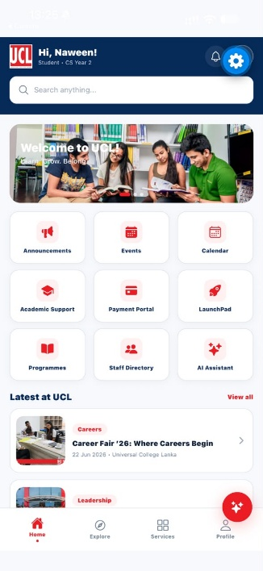
7. User Experience and Feature Flow
7.1 Student Journey
Login
↓
Student Dashboard
↓
Announcements / Events / Academic Calendar
↓
Academic Support / Staff Directory / IT Support
↓
Schedule Updates
↓
AI Assistant when additional guidance is required
The student experience was designed around a dashboard-first approach. After entering the platform, students are given direct access to the major information categories included within the project scope. This reduces the need to remember which communication channel contains a particular type of information.

7.2 Example Student Scenario
A student who needs to determine whether an academic schedule has changed can access the platform and view current schedule updates. If the student is unsure where to find the relevant information, the AI Assistant provides an additional conversational method of reaching the appropriate content.
Similarly, a student seeking academic or technical assistance can access either the Academic Support or IT Support section and, where necessary, use the Staff Directory to locate the appropriate contact.
8. Design Process
8.1 Problem Analysis
The design process began by examining the underlying business problem described by UCL. The primary issue was not simply the absence of individual services; rather, students currently obtain information through several disconnected channels. The team therefore approached the project as an information-centralization challenge.

8.2 Information Architecture
The selected requirements were grouped according to the type of information students would be attempting to access.
Communication
- Targeted Announcements
- Schedule Changes
Campus Activity
- Event Visibility
Academic Information
- Academic Support
- Academic Calendar
Support & Contacts
- Staff Directory
- IT Support Information
Platform Services
- Unified Access
- Access Levels
- AI Assistant

8.3 Interface Design Principles
The user interface was designed around simplicity, discoverability and consistency. Since the brief requires the solution to be usable by first-time students with different levels of digital literacy, navigation was kept clear and major information categories were made directly accessible through the main dashboard.
- Clear navigation
- Consistent page structure
- Readable text
- Minimal unnecessary steps
- Visible important information
- Responsive layouts
- Familiar icons and labels

8.4 Iterative Development
You need a genuine example here.
Template:
During implementation, the team initially designed calendar. Testing identified the calendar not getting marked `, which resulted in changing the data in the folder ( calendar function in the code was changed ). The revised design improved the usage of calendar being able to use and being marked .
Figure 2. Initial Design Compared with Final Interface
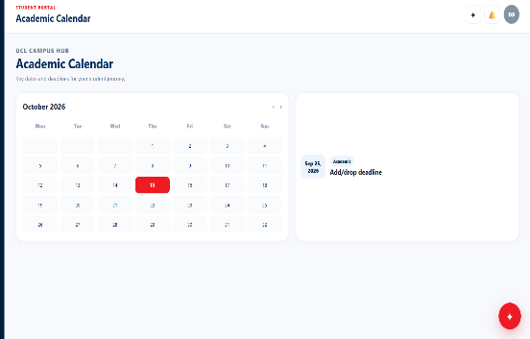

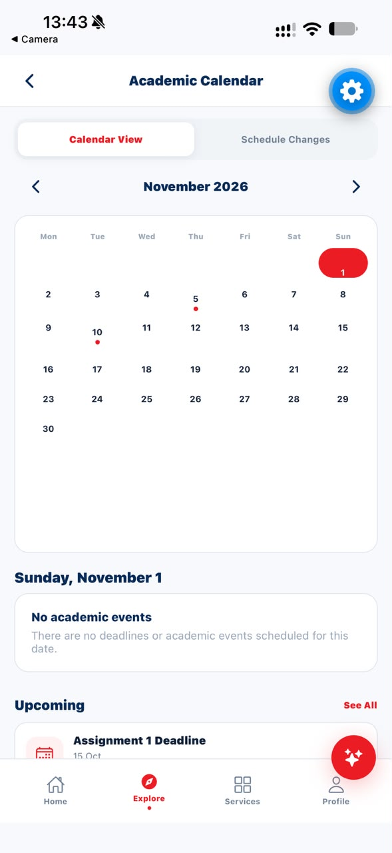
9. System Architecture

USERS
┌─────────┴─────────┐
│ │
STUDENT STAFF
│ │
└─────────┬─────────┘
▼
FRONTEND WEB APP
│
API CALLS
│
▼
BACKEND API
│
┌─────────────┼─────────────┐
▼ ▼ ▼
DATABASE AUTHENTICATION AI SERVICE
│
▼
Campus Information

The platform follows a client-server architecture. The frontend provides the user-facing interface through which students and staff interact with the system. The backend is responsible for processing application requests, enforcing access rules and communicating with the application's data layer.
Authentication and access-control mechanisms are used to distinguish between user types. The AI component communicates through the application layer to support conversational information discovery.

